Name: Salman Almutairi

ID: 2202117608

Homeword: 1

1. Describe the C++ development phases.

1) Analysis and Design

2) Implementation

3) Testing

4) Maintenance

2. Write the size of the following data types.

a. char: 1 byte

b. short: 2 bytes

c. int: 4 bytes

d. long: 8 bytes

e. float: 4 bytes

f. double: 8 bytes

3. Give an example of each data type in Question 2 by declaring and initializing the variables with the proper values.

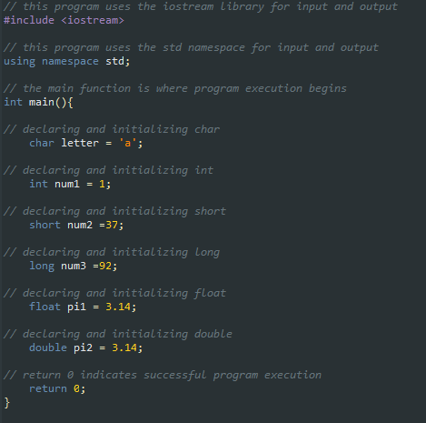

4. We can convert the Fahrenheit degree into Celsius using the following formula:  
°C = (°F − 32) × 5/9

Also, we can convert the Celsius degree into Fahrenheit using the following formula:  
°F = °C × 9/5 + 32

Write a C++ program that reads a temperature value as input and its type (either Celsius “C” or  
Fahrenheit “F”) and then the program must convert the value to the other type. Examples of a  
running program:

1. Enter temperature value: 33.5  
   Enter temperature type: C  
   The 33.5 Celsius is equivalent to 92.3 Fahrenheit
2. Enter temperature value: 77.6  
   Enter temperature type: F  
   The 77.6 Fahrenheit is equivalent to 25.3333 Celsius

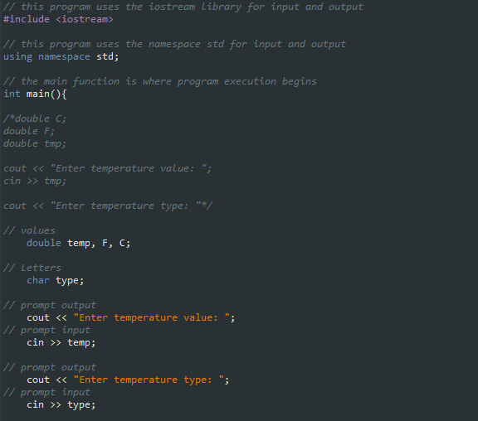

5. Consider a father has died and left his money to his wife, 3 sons, and 6 daughters. Based on

Islamic’s Sharia, write a C++ program that takes a none integer value and then computes the

inheritance ( ثاریملا .( Your program shall output the share of each of wife, son, daughter, total sons

share, and total daughter share. Note that the shares can be computed as follows: the wife has a

share of 1/8 whereas the rest of the share will be divided between the sons and daughter such that

sons get double amount of daughters.

Below is an example of a program input/output:

Enter the inheritance value: 1000

The wife share is: 125.000

The share of each son is: 145.830

The total share of sons is: 437.490

The share of each daughter is: 72.920

The total share of daughters is: 437.510

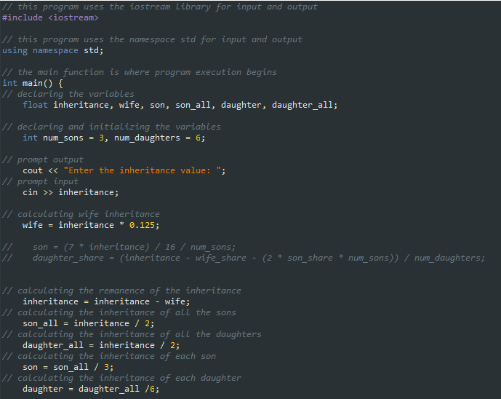

6. Use the table below to convert the GPA into letter grade. Write a C++ program that takes a

number with decimals that represents the GPA and then converts it into a grade using if-else

statements. The program must output “unknown GPA, exiting program...” to any

entered number greater than 4 or less than 1.

GPA Grade

4.0 A

3.67 A3.33 B+

3.0 B

2.67 B2.33 C+

2.0 C

1.67 C1.33 D+

1 D

Examples of program output

• Enter GPA: 3.45

Your grade is A-

• Enter GPA: 0.5

Unknown GPA, exiting program...



